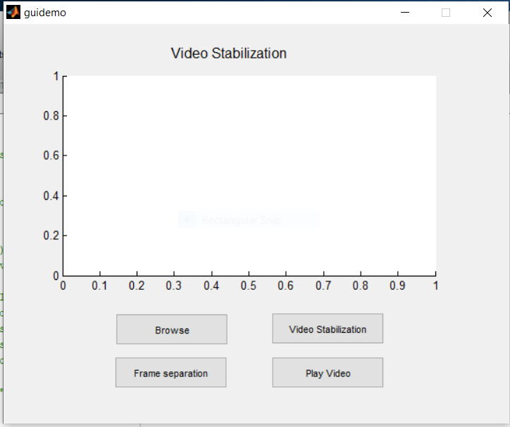

**Step 1 : Default GUI Window**

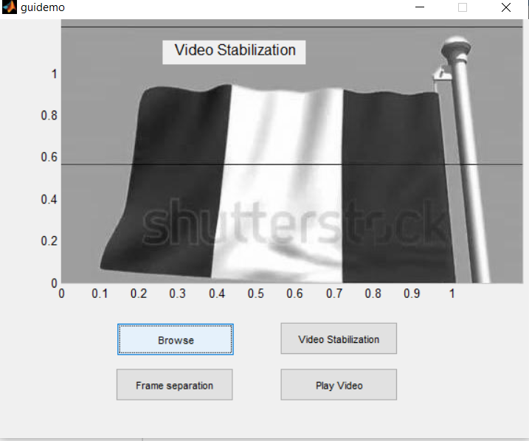

**Step 2 : Select the Video to be stabilized**

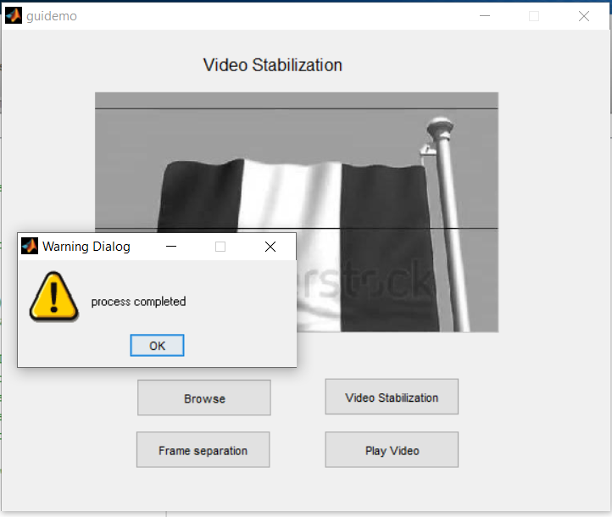

**Step 3 : Frame Separation**

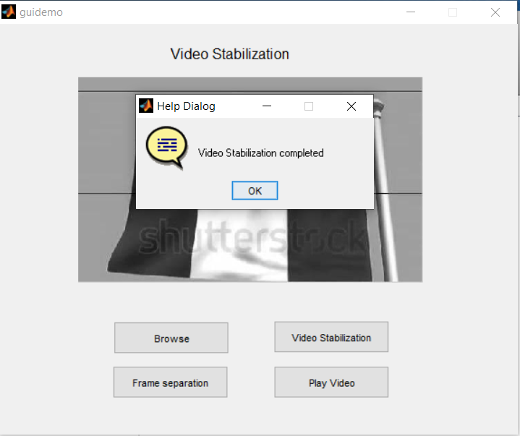

**Step 4 : Video Stabilization Process**

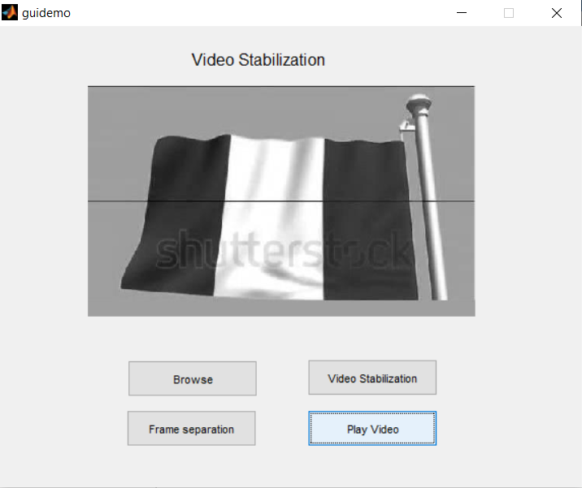

**Step 5 : Play Stabilized Video**